Library Management Data Analysis - Odin Library Database

Tools Used: MySQL Workbench
Objective: Analyze library operations to generate actionable insights using advanced SQL features including joins,aggregation, subqueries, conditional logic (CASE WHEN),window functions, GROUP BY, HAVING, ORDER BY, LIMIT, and date calculations.

Project Overview
The ODIN Library Management System project is a structured SQL-based analysis project designed to understand and manage a library’s operations efficiently.
The dataset includes multiple interrelated tables such as Books, Members, Loans, Fines, Library Branches, Staff, Authors, Categories, and Reservations.
This project focuses on generating meaningful insights through SQL queries — from member activity to book popularity, overdue analysis, and category insights.

Objective
The objective of this SQL project is to:
• Understand the working of a library database.
• Apply SQL concepts like joins, subqueries, group by, aggregate functions, window functions, and case statements.
• Analyze different operational areas like member activity, book performance, category trends, staff performance, and payment patterns.

Database Structure
Database Name: Odin Library
Tables Used:
1. Authors – Stores details of authors.
• Columns: AuthorID, AuthorName
2. Books – Contains book information.
• Columns: BookID, Title, AuthorID, Genre
3. Categories – Represents book categories or genres.
• Columns: CategoryID, CategoryName
4. LibraryBranches – Information about library branches.
• Columns: BranchID, BranchName
5. Members – Details about members who borrow books.
• Columns: MemberID, MembersNames
6. Loans – Tracks book borrowings and returns.
• Columns: LoanID, BookID, MemberID, BranchID, LoanDate, DueDate, Return Date
7. Fines – Tracks fines imposed on members for overdue books.
• Columns: FineID, MemberID, DueDate
8. Reservations – Information about book reservations.
• Columns: ReservationID, BookID, MemberID
9. Staff – Staff managing different branches.
• Columns: StaffID, Names, BranchID,
10 Bookscategories – Informatiom about books and categories
• Columns: BookID, CategoryID

Modules and Queries
The project consists of 5 major modules and 12 SQL queries.

Table of Contents

1. Module 1 – Member Activity Analysis
2. Module 2 – Book Popularity Analysis
3. Module 3 – Category & Branch Insights
4. Module 4 – Fines & Payment Analysis
5. Module 5 – Staff & Reservation Analysis

Module 1: Member Activity Analysis
Objective: Identify active members and borrowing patterns.
Query 1: Top Members by Books Borrowed Last Year.
SQLCODE:
SELECT firstname , lastname ,count(loanid)
AS books_borrowed from members
INNER JOIN loans
ON loans.MemberID=members.MemberID
WHERE year (LoanDate) = 2024
GROUP BY firstname,lastname
ORDER BY books_borrowed desc
LIMIT 5;
Insight : Highlights most engaged members in the past year,
useful for reward programs.
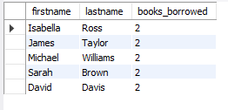
Query 2: Members with Overdue Books
SQLCODE:
SELECT m.MemberID, m.FirstName, m.LastName, b.Title, l.LoanDate
l.DueDate , l.ReturnDate,
CASE
WHEN l.ReturnDate IS NULL AND l.DueDate < CURDATE()
THEN 'Overdue (Not Returned)'
WHEN l.ReturnDate > l.DueDate THEN 'Overdue (Returned Late)'
END AS Current_Status
FROM members m
INNER JOIN loans l ON m.MemberID = l.MemberID
INNER JOIN books b ON l.BookID = b.BookID
WHERE (l.ReturnDate IS NULL AND l.DueDate < CURDATE())
OR (l.ReturnDate > l.DueDate)
ORDER BY l.DueDate DESC;

Insight: Highlights members who have not returned books on time, helping staff manage overdue follow-ups and fines.

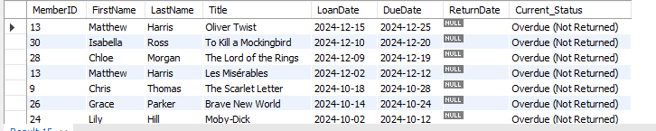

Query 3: Ranking Top Borrowers
SQLCODE:
SELECT m.MemberID, m.FirstName, m.LastName,
COUNT(l.LoanID) AS top_borrowers,
RANK() OVER (ORDER BY COUNT(l.LoanID) DESC) AS borrow_rank
FROM loans l
INNER JOIN members m
ON l.MemberID = m.MemberID
GROUP BY m.MemberID, m.FirstName, m.LastName
ORDER BY top_borrowers DESC;

Insight: Ranks members based on the total number of books borrowed, allowing performance comparison and loyalty tracking.

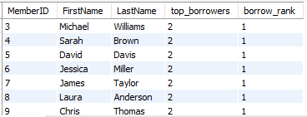

Module 2: Book Popularity and Circulation
Objective: To determine which books are most or least in demand and evaluate circulation performance.
Query 4: Top 10 Most Borrowed Books
SQLCODE:
SELECT books.bookid, books.title, COUNT(LOANID) AS most_borrowed_books
FROM books
INNER JOIN loans ON books.bookid = loans.bookid
GROUP BY books.bookid, books.title
ORDER BY most_borrowed_books DESC
LIMIT 10;

Insight: Displays the top-performing books based on the number of times borrowed, reflecting reading trends.

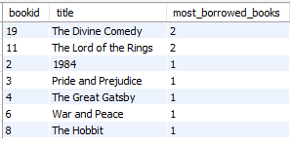

Query 5: Books Not Loaned Out in the Last Six Months
SQLCODE:
SELECT title
FROM books
WHERE bookid NOT IN( SELECT bookid FROM loans
WHERE loandate >= "2025-09-30");

Insight: Helps identify less popular or outdated books that may need replacement or promotion.

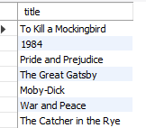

Module 3: Category and Branch Insights
Objective: To analyze performance differences across branches & categories.
Query 6: Most borrowed categories
SQLCODE:
SELECT categories.categoryname, COUNT(loans.LoanID) AS TotalLoans
FROM bookcategories
INNER JOIN Categories
ON bookcategories.CategoryID = categories.CategoryID
INNER JOIN books
ON books.bookid = bookcategories.bookid
INNER JOIN Loans
ON books.bookid = loans.bookid
GROUP BY categories.CategoryName
ORDER BY TotalLoans DESC;

Insight: Helps the library identify which book categories are in highest demand.

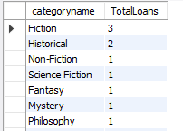

Query 7: Branch wise loan analysis
SQLCODE:
SELECT BranchName, count(loanid) AS total_Loan
FROM librarybranches
LEFT JOIN loans
ON loans.BranchID = librarybranches.BranchID
GROUP BY BranchName
ORDER BY total_Loan DESC;

Insight: : Shows how many books were borrowed per branch, indicating branch-level performance and reader engagement.

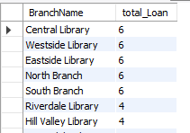

Module 4: Financial and Fine Management
Objective: To track fines, payments, and related financial aspects of library operations.
Query 8: Total Fines per Member
SQLCODE:
SELECT members.memberid , members.firstname , members.lastname, sum(fines.FineID) AS totalfines
FROM members
INNER JOIN fines
ON fines.memberid = members.memberid
GROUP BY members.memberid ,members.firstname ,members.lastname
ORDER BY totalfines DESC;

Insight: Summarizes total fines for each member, assisting in managing outstanding payments.

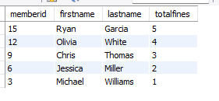

Query 9: Average Number of Days Books Are Kept
SQLCODE:
SELECT avg(returndate-loandate) AS AvgDaysKept
FROM loans
WHERE returned =1;
Insight: Calculates average loan duration, helping understand member behavior and book turnover rate.

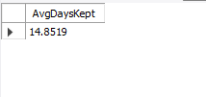

Query 10: Members with Fines Above 10
SQLCODE:
SELECT members.memberid , members.firstname, members.lastname,
SUM(fines.amount) AS total_fines
FROM members
INNER JOIN fines
ON members.memberid = fines.memberid
GROUP BY members.memberid, members.firstname, members.lastname
HAVING SUM(fines.amount) > 10;

Insight: Identifies members with high fines to help enforce timely returns and payment policies.

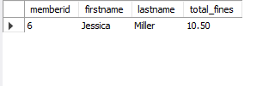

Module 5: Staff and Reservation Insights
Objective: To evaluate staff performance and reservation activities.
Query 11: Staff Handling Most Loans
SQLCODE:
SELECT staff.staffid, staff.firstname , staff.lastname,
COUNT(loans.loanid) AS loans_handled
FROM staff
INNER JOIN librarybranches
ON staff.branchid = librarybranches.branchid
INNER JOIN loans
ON librarybranches.branchid = loans.branchid
GROUP BY staff.staffid, staff.firstname, staff.lastname
ORDER BY loans_handled DESC;

Insight: Finds the staff members responsible for the most transactions, highlighting efficiency and workload distribution.

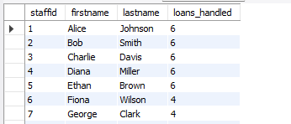
Query 12: Reservations per Member
SQLCODE:
SELECT members.memberid, members.firstname ,members.lastname, count(reservationid) AS TotalReservations
FROM members
LEFT JOIN reservations
ON reservations.memberid = members.memberid
GROUP BY memberid, firstname, lastname
ORDER BY TotalReservations DESC;

Insight: Measures how often members reserve books, showing proactive interest and engagement patterns.

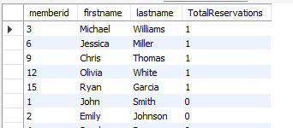

Conclusion

The ODIN Library SQL project provided a comprehensive analytical overview of the library’s functioning.
By using structured SQL queries and relational joins, this project generated actionable insights into member activities, book circulation, branch performance, and staff operations.
It demonstrates the importance of SQL in data-driven decision-making and highlights how database analysis can optimize library management and improve overall efficiency.

